DREAM BIG FOR YOUR KIDS 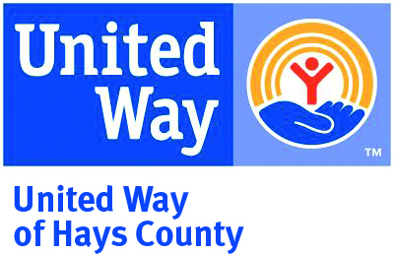
BORNLEARNING ACADEMY

REGISTRATION FORM
Register by September 3rd, 2018 by emailing this form to analia.voss@uwhays.org or mailing it to United Way of Hays & Caldwell Counties, P.O. Box 1728, San Marcos, Tx 78667

PARENT NAME (S):______________________________________________________________________________

STREET ADDRESS: ______________________________________________________________________________

CITY: _________________________________________ STATE: _________________________ ZIP: ____________

PHONE NUMBER: ______________________________________________________________________________

EMAIL: _______________________________________________________________________________________

LIST ALL CHILDREN 5 YEARS OLD OR YOUNGER:

CHILD 1 NAME: _______________________________________ BIRTHDAY (DAY/MONTH/YEAR) _____________

CHILD 2 NAME: _______________________________________ BIRTHDAY (DAY/MONTH/YEAR) _____________

CHILD 3 NAME: _______________________________________ BIRTHDAY (DAY/MONTH/YEAR) _____________

ATTENDING DINNER?

YES NUMBER_______________

NO

DO OU NEED CHILD CARE FOR YOUR CHILDREN?

YES NUMBER OF SCHOOL AGE CHILDREN _________ AGES _____________
NUMBER OF SCHOOL AGE CHILDREN _________ AGES _____________

NO

Sign me up to receive 2 emails per month on how to make everyday moments teaching moments, your child’s development milestones, and learn about local family events happening.

NOTE: Space limited to 20 families. First come, first served. If you are not one of the first 20 families, you will be contacted and added if you wish to the wait list for the summer 2017 workshops.

